*Submitting Maine WOIA ETP Report*

# 6/19/2018 Updated: 3/6/2021

*Before submitting your data, you must make sure you have a data sharing account. If you don’t yet have an account you can find instructions for creating one here*[*: CreateNewOrganization.pdf (maine.gov)*](https://www.maine.gov/labor/cwri/etp/docs/CreateNewOrganization.pdf)

1. Sign into you MaineEARNS Data Submission Site Account: [https://www1.maine.gov/cgibin/online/cwri/start/](https://www1.maine.gov/cgi-bin/online/cwri/start/)
2. Generate two files with the following requirements:

**File one: Details file**

Contains essential information on participants for WIOA reporting without the SSN

|  |  |  |  |
| --- | --- | --- | --- |
| **Column** | **Column Header** | **ETP Definition** | **Notes** |
| AHD1 | organization_code | organization code | Provided by BES |
| AHD2 | id_number | **Unique** student identifier. | Training providers must have a unique identifyer for each student |
| AHD3 | date_of_completion | completion date, formatted YYYYMMDD |  |
| AHD4 | cip_code | 6 digit cip code representing the student's program |  |
| AHD5 | program_code | optional |  |
| AHD6 | program_description | Written description of the program |  |
| AHD7 | credential | Values 0-9. See notes for details. | 1. = A program of study leading to an industry-recognized certificate or certification 2. = A program of study leading to a certificate of completion of an apprenticeship 3. = A program of study leading to a license recognized by the   State involved or the Federal Government,   1. = A program of study leading to an associate degree 2. = A program of study leading to a baccalaureate degree 3. = A program of study leading to a community college certificate of completion 4. = A program of study leading to a secondary school diploma or its equivalent 5. = A program of study leading to employment 6. = A program of study leading to a measureable skills gain leading to a credential   0 = A program of study leading to a measureable skills gain leading to employment |
| AHD8 | completion_indicator | Values 1-4. See notes for details. | 1. = completed 2. = exited 3. = transferred   • 4 = other |

**File two: Cross Reference file**

Allows DOL to retrieve the participant’s Social Security Number to match wages for complete reporting.

|  |  |  |  |
| --- | --- | --- | --- |
| **Column** | **Column Header** | **ETP Definition** | **Notes** |
| AHC1 | organization_code | organization code | Provided by BES. Must match organization code from details file. |
| AHC2 | id_number | unique student identifier. Must be unique | Schools must have a unique identifier for each student. Must match id_number from details file. |
| AHC3 | ssn | Social Security Number | Numeric. Do not include dashes |

**Both files must be saved as a .csv**

1. On the Upload Organization Files verify the correct Organization Information is displayed and select

“ETP File Upload” in the Uploads box so it is highlighted in Blue. *, **

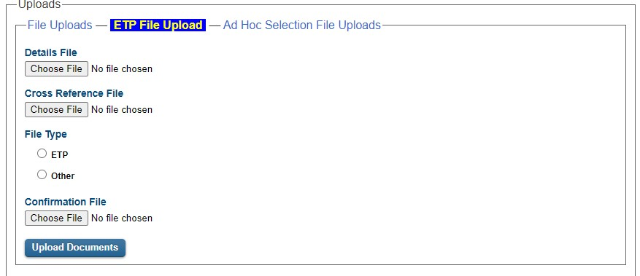

*As an ETP you are required to submit **both** a Details File and Cross Reference File.

** Make sure to select ETP under File Type before clicking “Upload Documents”. *(Confirmation File is not required for this type of upload.)*

Click “Upload Documents” to complete file submission.

See next page

If you have done this successfully, you will receive a confirmation number as seen below.

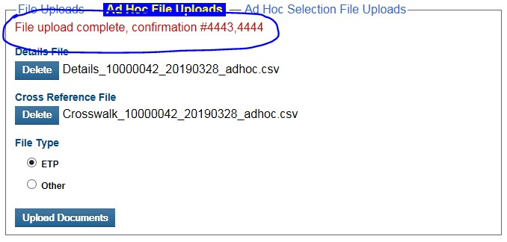

If you were unsuccessful, you will receive an error. The most common types of errors are

1. You’ve submitted the file to the wrong location. For example, you submitted you Details file in the Cross Reference file section.
2. Your file is not a .csv or .xml. A CSV or XML file ***is required*** for submission through the data submission site.
3. Your column headers are wrong. Please use the column headers from page 1. Please remember the column headers are all lowercase and spaces are replaced with an underscore ( _ ) .

If you have any questions about file submission, you may contact the data submission site administrator. Their information is in the footer of the website page.